**Assignment -4**

|  |  |
| --- | --- |
| Assignment Date | 02 November 2022 |
| Maximum Marks | 2 Marks |
| Team ID | PNT2022TMID17100 |

# Question:

Write code and connections in wokwi for the ultrasonic sensor. Whenever the distance is less than 100 cms send an "alert" to the IBM cloud and display in the device recent events. Upload document with wokwi share link and images of IBM cloud.

# Code:

#include <WiFi.h> #include <WiFiClient.h> #include <PubSubClient.h> const int trigPin = 27; const int echoPin = 26;

//define sound speed in cm/uS #define SOUND_SPEED 0.034

#define CM_TO_INCH 0.393701 long duration;

float distanceCm; float distanceInch;

void callback(char* subscribetopic, byte* payload, unsigned int payloadLength);

//-------credentials of IBM Accounts------

#define ORG "z22obn"//IBM ORGANITION ID

#define DEVICE_TYPE "Assignment-ibm"//Device type mentioned in ibm watson IOT Platform

#define DEVICE_ID "Sensor"//Device ID mentioned in ibm watson IOT Platform #define TOKEN "12345678" //Token

String data3;

//-------- Customise the above values --------

char server[] = ORG ".messaging.internetofthings.ibmcloud.com";// Server Name

char publishTopic[] = "iot-2/evt/Data/fmt/json";// topic name and type of event perform and format in which data to be send

char subscribetopic[] = "iot-2/cmd/test/fmt/String";// cmd REPRESENT command type AND COMMAND IS TEST OF FORMAT STRING

char authMethod[] = "use-token-auth";// authentication method char token[] = TOKEN;

char clientId[] = "d:" ORG ":" DEVICE_TYPE ":" DEVICE_ID;//client id

WiFiClient wifiClient; // creating the instance for wificlient PubSubClient client(server, 1883, callback ,wifiClient);

void setup() {

Serial.begin(115200); // Starts the serial communication pinMode(trigPin, OUTPUT); // Sets the trigPin as an Output pinMode(echoPin, INPUT); // Sets the echoPin as an Input Serial.println();

wificonnect(); mqttconnect();

}

void loop() {

// Clears the trigPin digitalWrite(trigPin, LOW); delayMicroseconds(2);

// Sets the trigPin on HIGH state for 10 micro seconds digitalWrite(trigPin, HIGH);

delayMicroseconds(10); digitalWrite(trigPin, LOW);

// Reads the echoPin, returns the sound wave travel time in microseconds duration = pulseIn(echoPin, HIGH);

// Calculate the distance

distanceCm = duration * SOUND_SPEED/2;

// Convert to inches

distanceInch = distanceCm * CM_TO_INCH;

// Prints the distance in the Serial Monitor Serial.print("Distance (cm): "); Serial.println(distanceCm); Serial.print("Distance (inch): "); Serial.println(distanceInch);

PublishData(distanceCm); delay(1000);

if (!client.loop()) { mqttconnect();

}

}

void PublishData(float Cm) { mqttconnect();//function call for connecting to ibm

/*

creating the String in in form JSon to update the data to ibm cloud

*/

String payload = "{\"Distance (cm)\":"; payload += Cm;

payload += "}"; Serial.print("Sending payload: "); Serial.println(payload);

if (client.publish(publishTopic, (char*) payload.c_str())) {

Serial.println("Publish ok");// if it sucessfully upload data on the cloud then it will print publish ok in Serial monitor or else it will print publish failed

} else {

Serial.println("Publish failed");

}

}

void mqttconnect() {

if (!client.connected()) { Serial.print("Reconnecting client to "); Serial.println(server);

while (!!!client.connect(clientId, authMethod, token)) { Serial.print(".");

delay(500);

}

initManagedDevice();

Serial.println();

}

}

void wificonnect() //function defination for wificonnect

{

Serial.println(); Serial.print("Connecting to ");

WiFi.begin("Wokwi-GUEST", "", 6);//passing the wifi credentials to establish the connection

while (WiFi.status() != WL_CONNECTED) { delay(500);

Serial.print(".");

}

Serial.println(""); Serial.println("WiFi connected");

Serial.println("IP address: "); Serial.println(WiFi.localIP());

}

void initManagedDevice() {

if (client.subscribe(subscribetopic)) { Serial.println((subscribetopic)); Serial.println("subscribe to cmd OK");

} else

{

Serial.println("subscribe to cmd FAILED");

}

}

void callback(char* subscribetopic, byte* payload, unsigned int payloadLength)

{

Serial.print("callback invoked for topic: "); Serial.println(subscribetopic);

for (int i = 0; i < payloadLength; i++) {

//Serial.print((char)payload[i]); data3 += (char)payload[i];

}

}

# Wokwi Output:

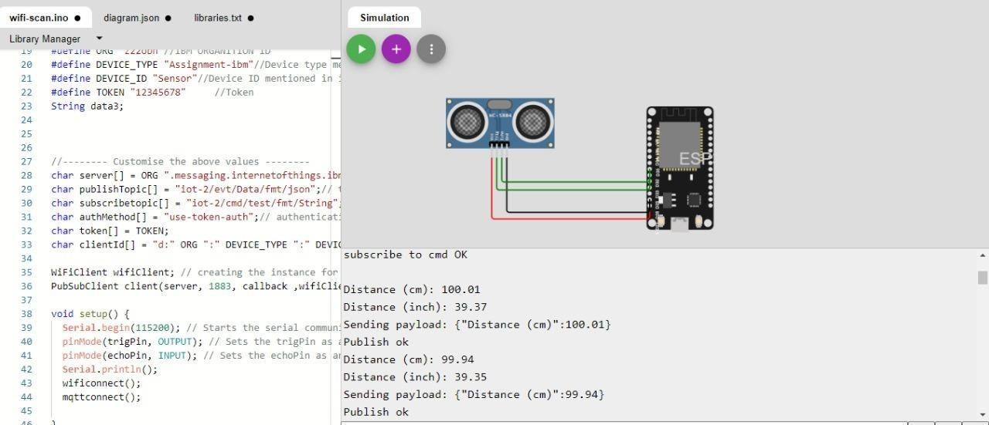

**IBM Cloud Alert:**

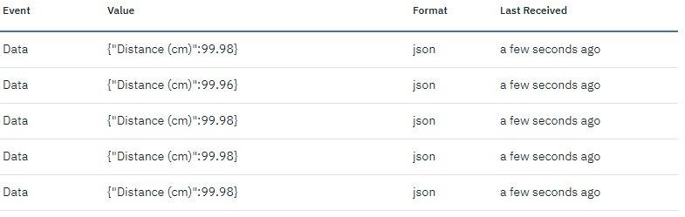

# Wokwi Share Link:

https://wokwi.com/projects/305569599398609473